Access from Twinkl using log-in details on letter sent home:
Twinkl is usually a paid subscription site but in the light of recent events it has very kindly been made available free to everyone for one month by using the following code UKTWINKLHELPS
Year 3 is Primary 4 but may be suitable to stretch your child.

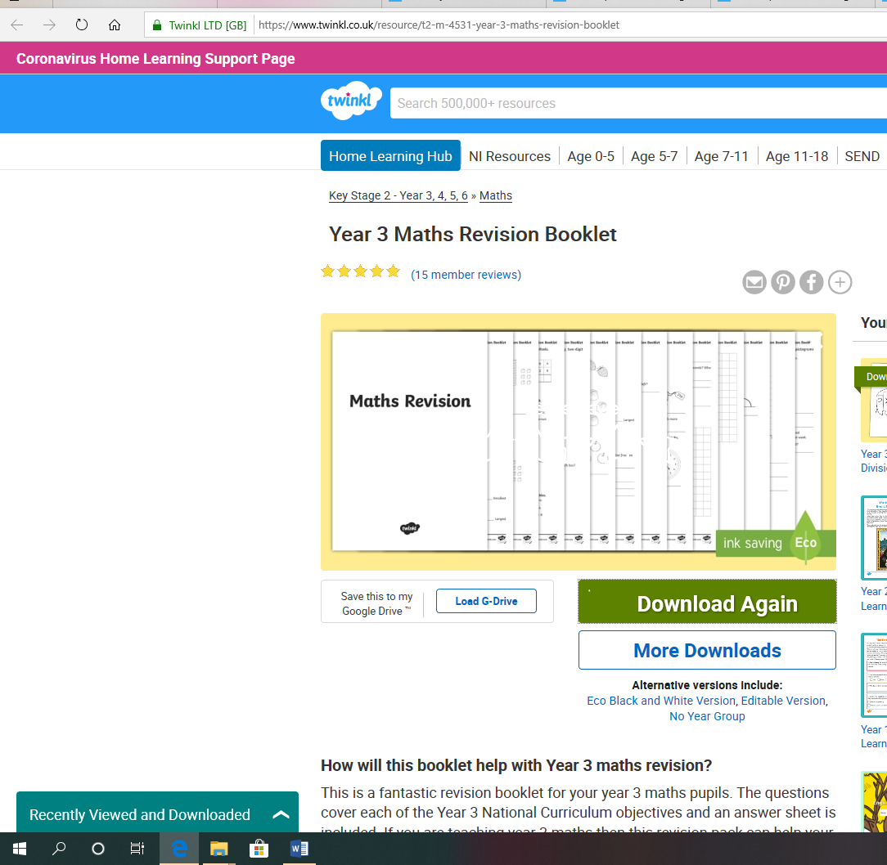

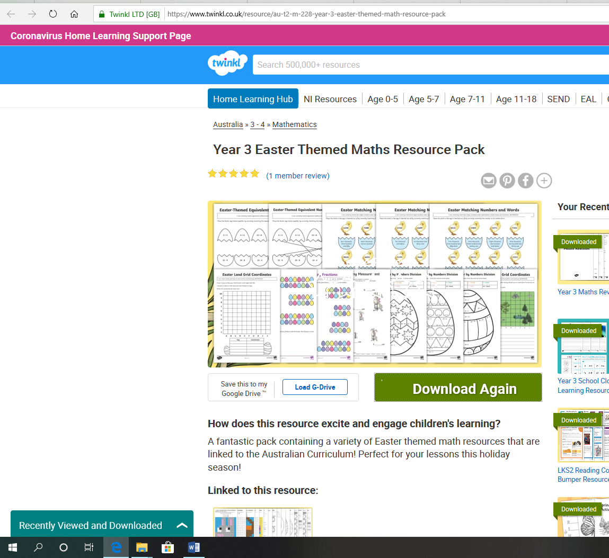

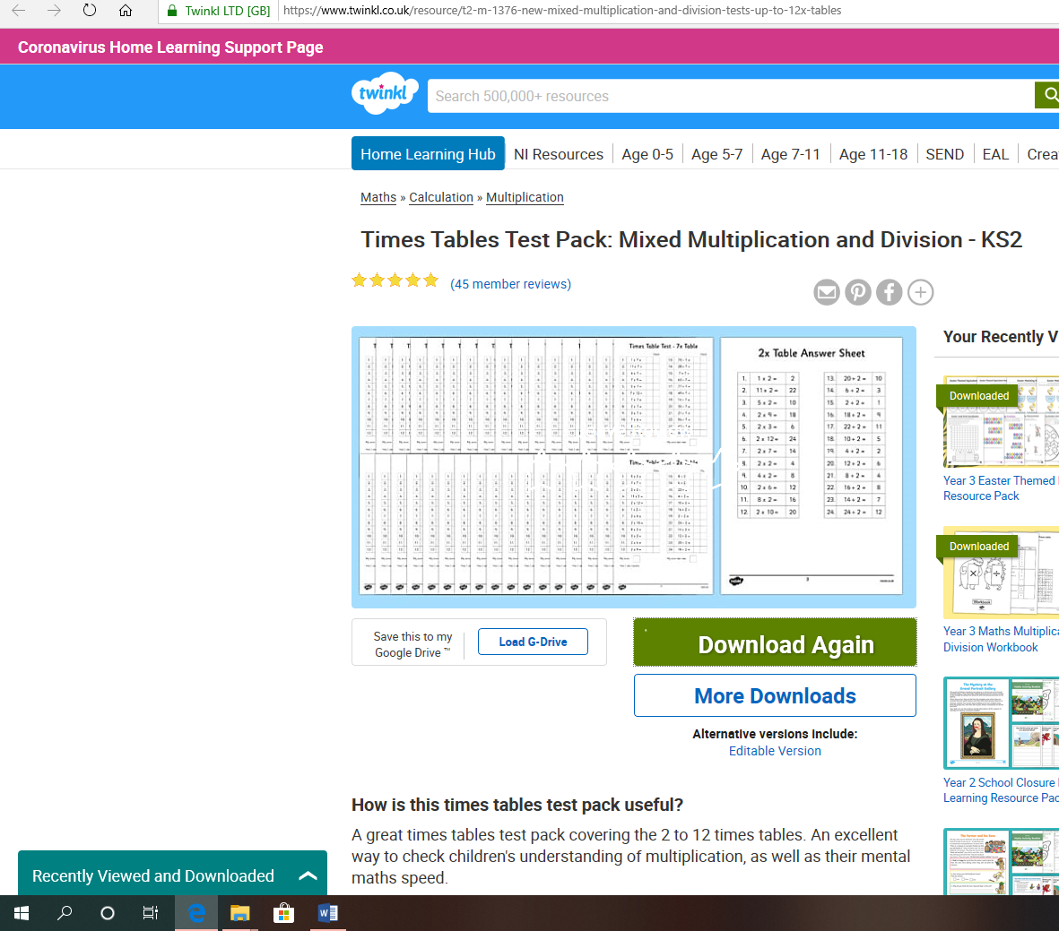

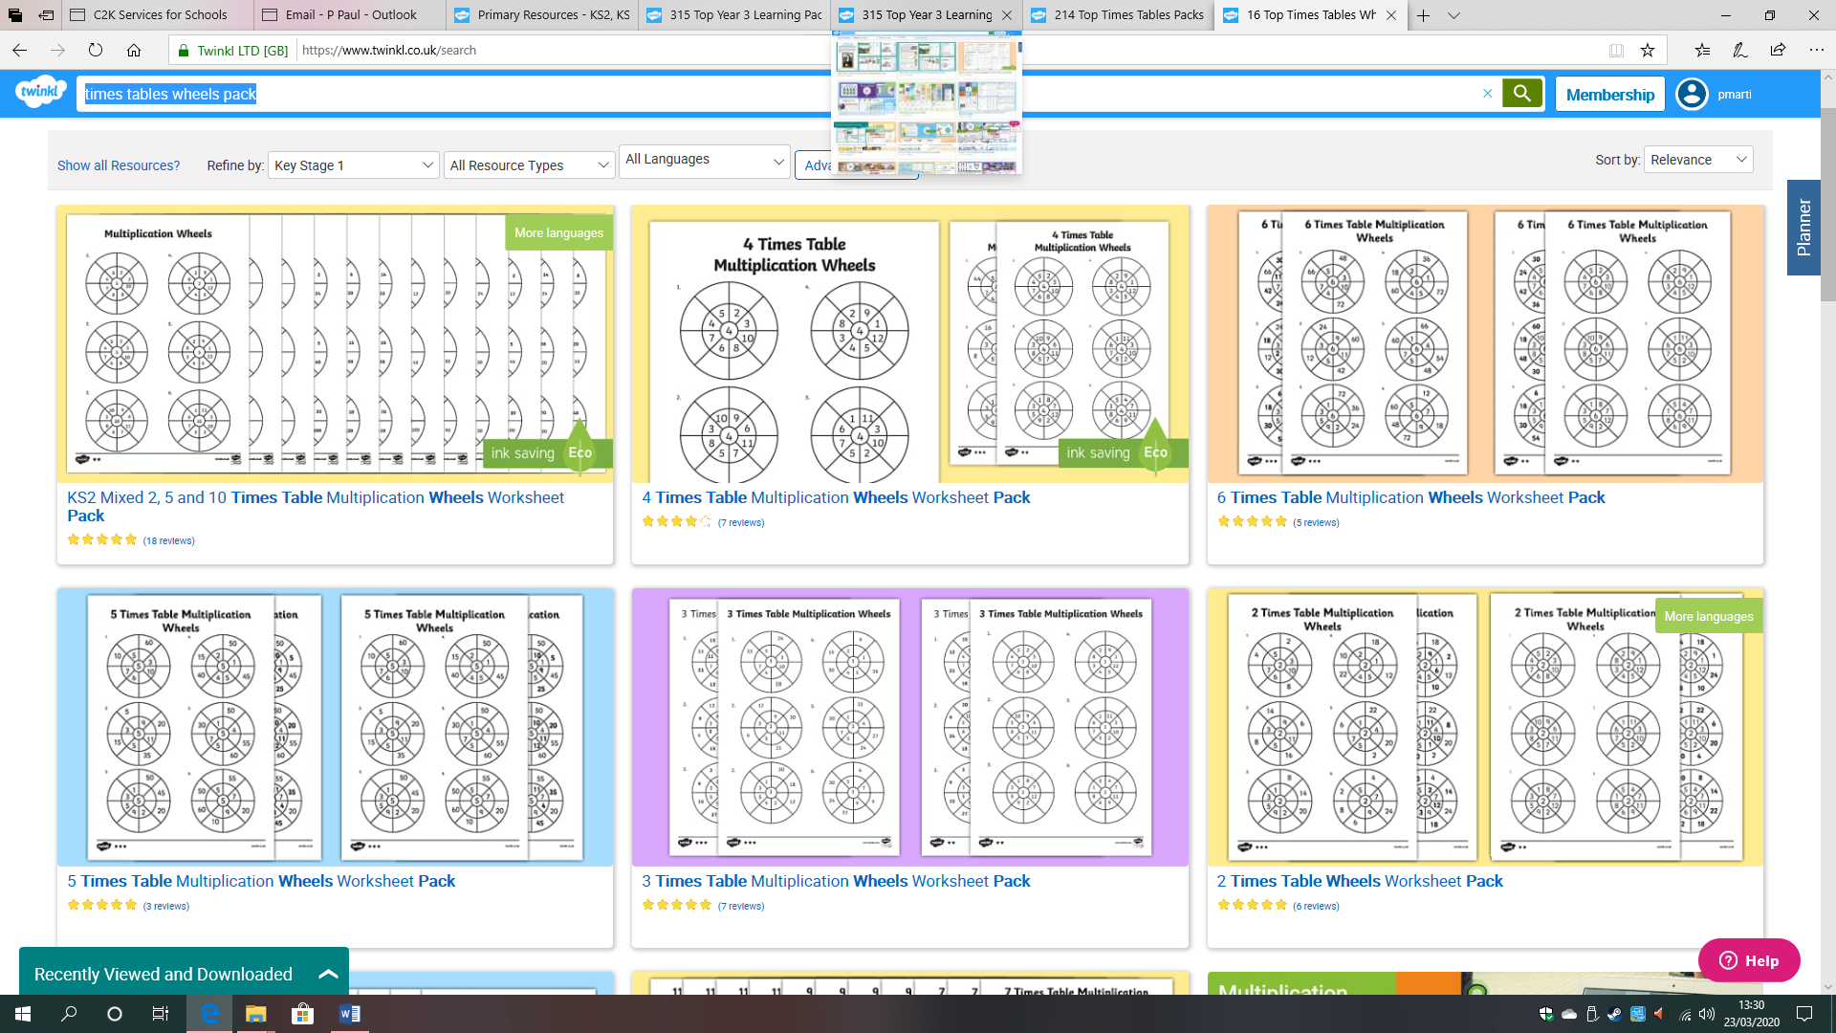

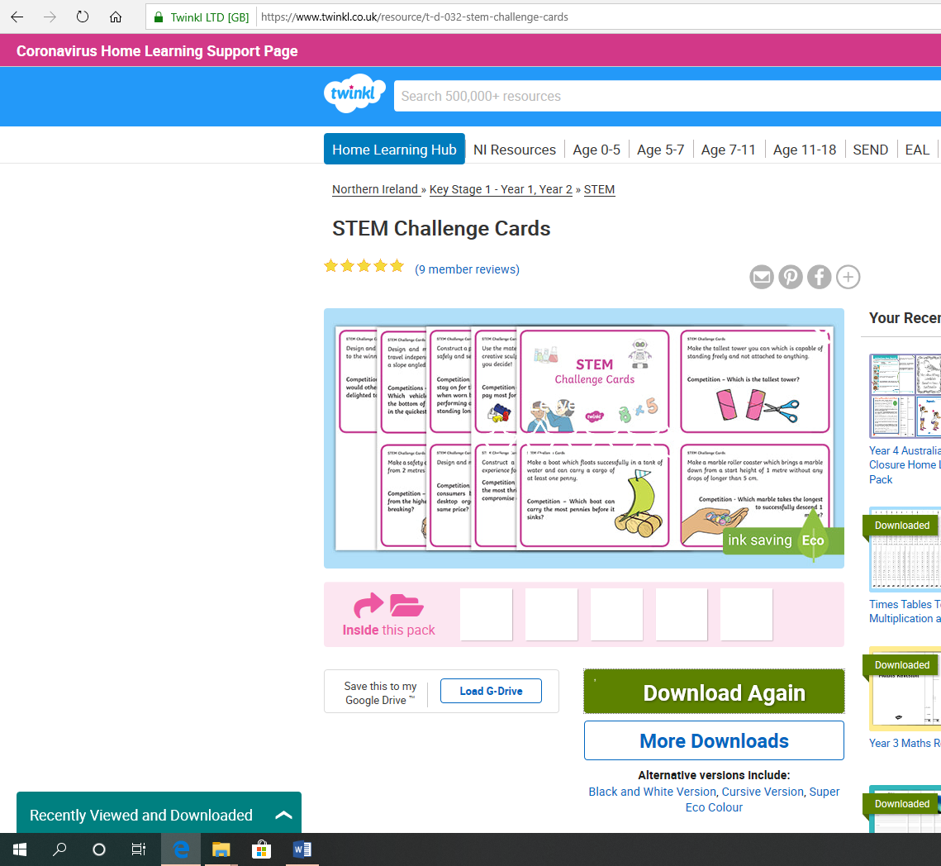

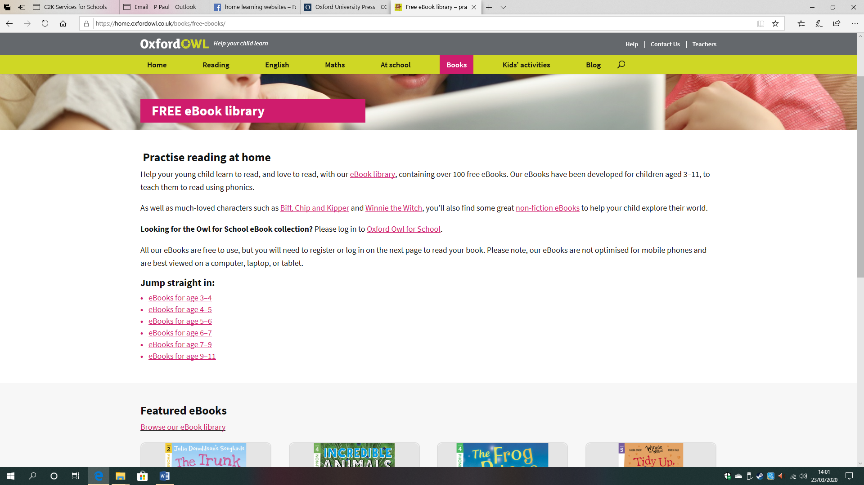
Reading materials can be found on https://home.oxfordowl.co.uk/books/free-ebooks/

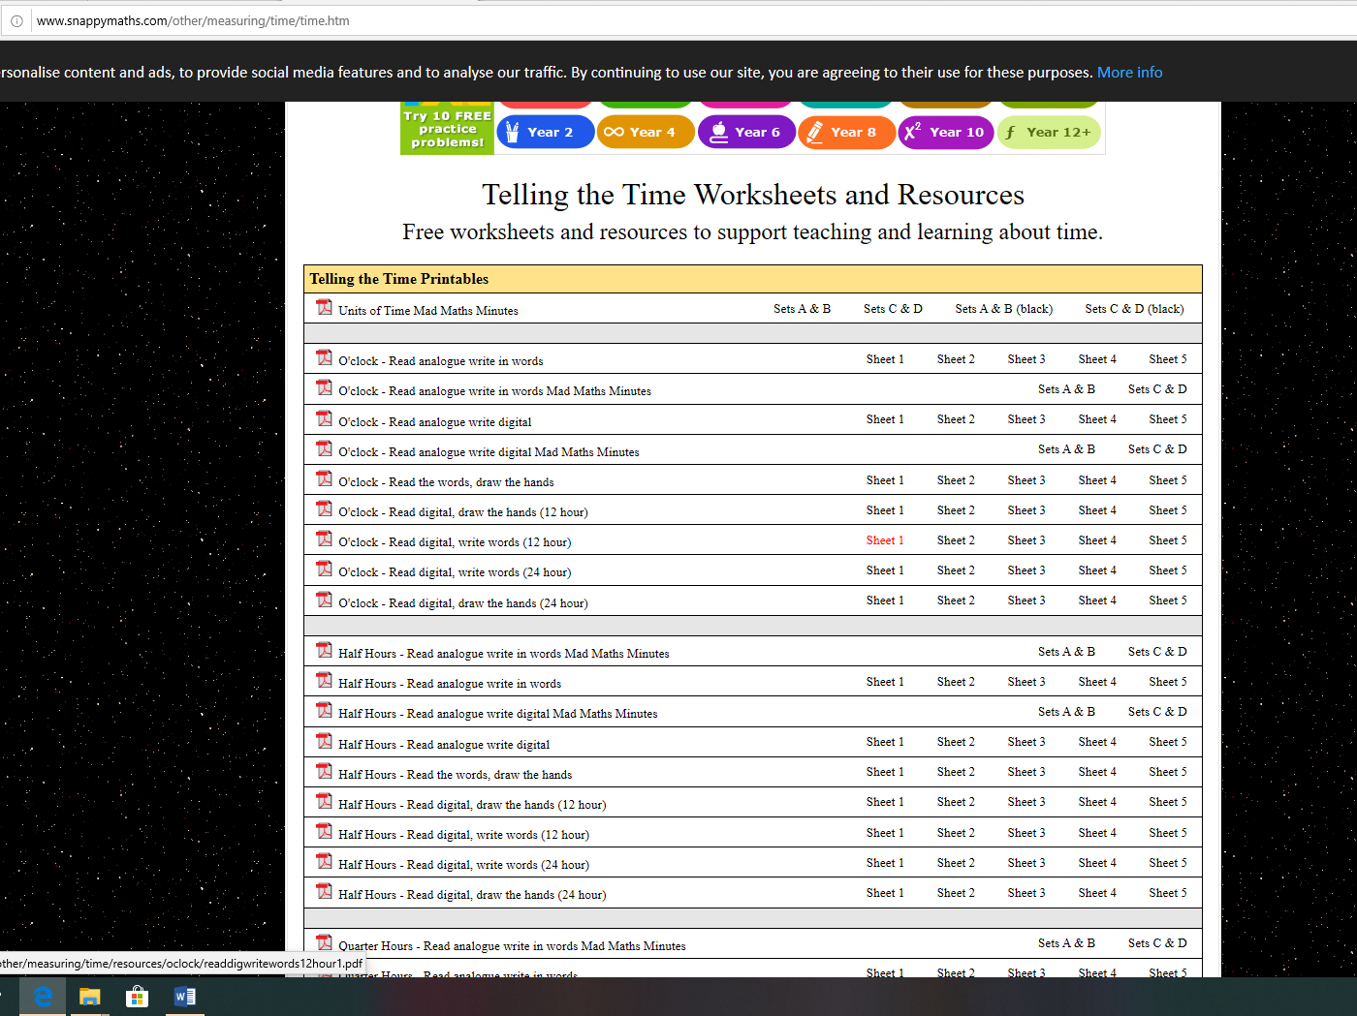

Printables from Snappy Maths (free) on telling the time – o’clock, half past, quarter to/past (P.3) and minutes past and to the hour (P.4)

