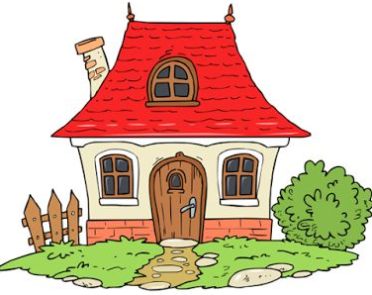
Dear Boys and Girls,
Mrs Woods and I are missing you all so much. But we are glad that you are staying at home keeping safe and well and looking after your grown-ups.
This month I have set you some new tasks, please find them below.
As we are missing you all, but we would love to see what you have been up to!
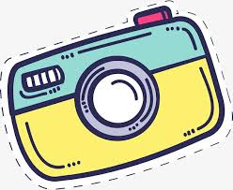
Mums and Dads, can you please take a photo of your child doing something they have really enjoyed during lockdown, perhaps playing in the garden, or on a daily walk or drawing a picture - you can decide.
If you send it to my school email address aherdman518@c2kni.net Mrs Woods will upload it onto our school face-book page so that you can all see what our friends have been doing!
We can’t wait to what you have been up too!
Missing you all lots,
Miss Herdman and Mrs Woods.
Numeracy
Practice counting with pieces of cereal, buttons, barbie shoes, lego etc. | Name the shapes of your food at each meal or snack time. | Count out 15 pieces of Lego. What can you build with it. | Draw a short flower and a tall flower. Draw a short tree and a tall tree. | Practice writing some numbers use chalk if you have some to write on the ground.
Draw 6 green worms and 5 red worms. How many have you all together? | Put a toy under your arm, above your head, beside your knee, around your wrist. | Collect some leaves & rocks. Make a pattern: rock. leaf, rock leaf, and so on…… | Build a tower with 5 blocks and a tower with 8 blocks. Which has more? Continue with other numbers. | Use play dough or cereal or sticks to make shapes. How many different shapes can you make?

Literacy
Choose a book and search for the first letter of your name. then try other letters? | Practice writing your name and other letters on paper, in sand or with chalk. | If you were a bird, where would you fly? Draw a picture. Tell someone about your picture. | Say or sing your favourite nursery rhyme. | Find an item in your house that begins with the sound ‘a’, ‘b’, etc.
Bingo make a bingo card using old magazines pictures, can your child find all the pictures | Make a rhyming string,  at, bat, cat, dat, fat, sat. Don’t worry if they are nonsense words | Make letters using play dough, buttons or dried peas. | make a book with folded paper, draw pictures and write letters, tell your story to a family member. | Bury letters in a sand box or around the house. Can your child find them?
Science
Draw what you see in the sky at night. Draw what you see in the sky during the day. | Test objects in water to see if they float or sink. Try a spoon, a sponge, toy, leaf, block etc. | Place a wet paper towel on a plate or on a zip lock bag add some cress seeds and watch them grow. Sunflowers are also easy to grow. | make a bubble solution with 1 spoonful of dish soap and ¾ cup of water. Stir. Use finger and thumb to blow bubbles. | Build a ramp with blocks or a board and test objects to see which will roll.
Pour milk into bowl (cover the bottom) add drops of food colouring on edges, dip toothpick in soap and dip it in the milk. | Place different objects in a sock. Feel without looking and guess what it is. | Pour different amounts of water into 6 glasses. Add food colouring. tap the glasses with a wooden spoon. Can you make music? | Draw something you can taste, something you can see, hear, smell and touch. | Go on a minibeast hunt. How many different minibeast can you find,

Fine Motor Skills
Put lego’s or snap cubes together. | Pick up cheerio’s or marshmallows with tweezers.  move from one bowl to another. | Practice buttoning shirt and putting up zips. | Pop bubble wrap. | Play with play dough or clay.
Cut out pictures from magazines or catalogue and glue onto paper. | Punch holes in paper with toothpick. | Go on a tweezer track. See what you can pick up in your garden with your tweezers. | Slice a banana with a butter knife, butter bread and make a banana sandwich. | Threading pasta to make a necklace.

Art
Paint a picture  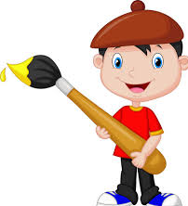 | Draw with crayons, | Draw in the dirt with a stick. | Draw on the ground with chalk | Create 3-D art using toilet roll tube, boxes, foil, coloured paper, ribbons etc.
Using large household paint brushes, water and food colouring, paint the garden fence, | Glue two wiggley eyes onto paper. Then come up with a person or animal to draw. | Use cotton buds to paint polka dots art. | Make a rainbow collage by finding coloured pictures in magazines, | Make an animal from fruit or vegetables. You will need cocktail sticks to hold together.

Get Moving
Count to 10 while exercising: jumps, kicks, toe touches, etc | Dance to Go Noodle videos on YouTube. | Move like animals: frog, jump, crab walk, elephant walk, monkey swing, turtle crawl. | Dance fast  Dance slow | Play freeze: dance or run then stop when a family member says freeze.
Lay pillows on the floor and frog hop over them.  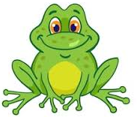 | Play the floor is lava. Move around the room without touching the floor, | Draw a line on the driveway with chalk. Make it Zig Zag and curved. Walk the line making sure to stay on it, | Dance along with your favourite song. | Play hopscotch.  

