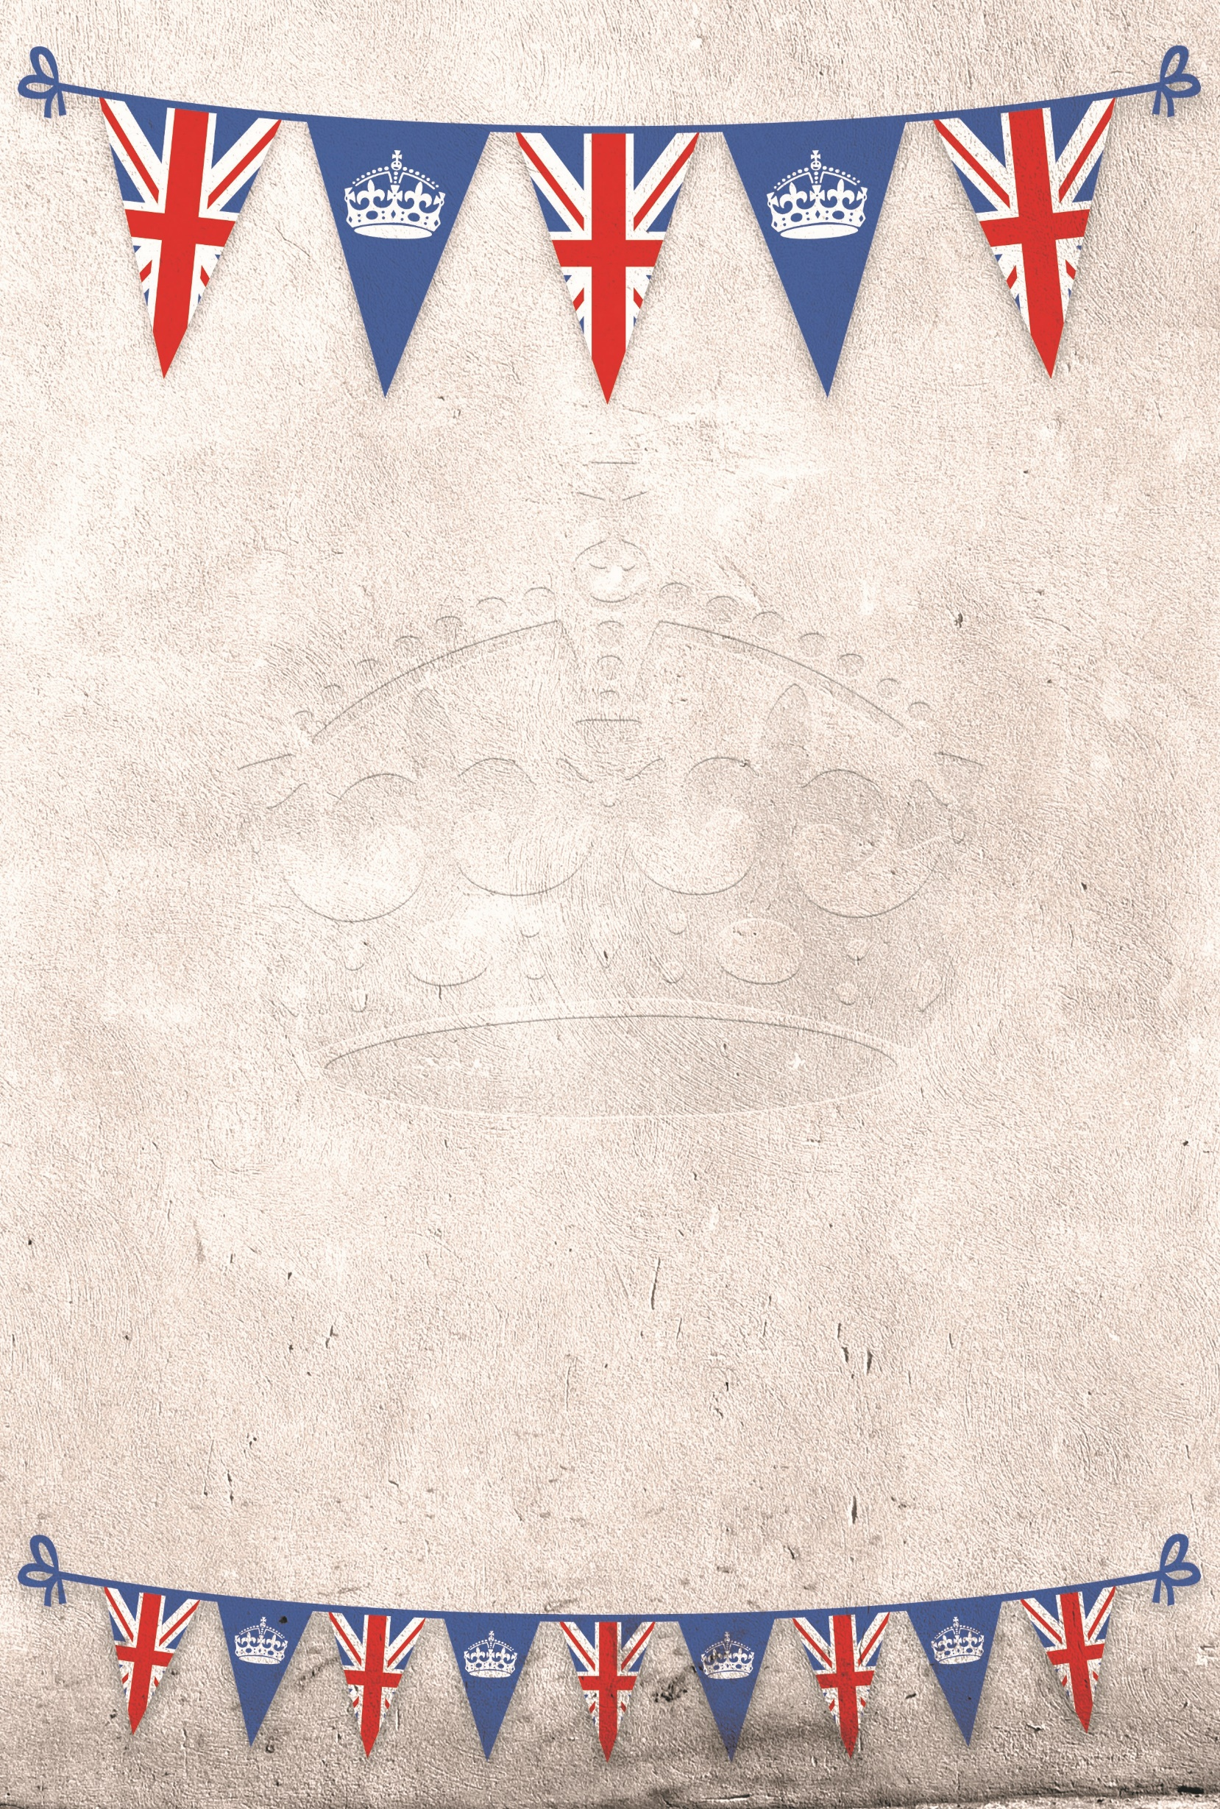

Queen Elizabeth’s

70th Jubilee School Party

Celebrations

Her Majesty’s Finest Hot Corgi Dogs

&

Soldier Fries

With Tomato Ketchup

Windsor Castle Garden’s

Carrot

&

Cucumber

Sticks with Dip

Royal Coronation Cookie Selection